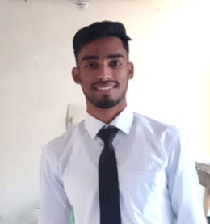**CV of SOHAG HOSSAIN SHANTO**

|  |  |  |
| --- | --- | --- |
| Name | : | SOHAG HOSSAIN SHANTO |
| Father’s Name | : | MD. FERDOUS ALI |
| Mother’s Name | : | Most. DULBI AKTER |
| Date Of Birth | : | 01/01/2001 |
| Nationality | : | BANGLADESHI |
| Religion | : | ISLAM |
| Marital Status | : | SINGLE |
| Gender | : | MALE |
| Mobile Number | : | 01764717373 |
| Email | : | nirbakceleshanto@gmail.com |
| Present Address |  | VILLAGE: UTTAR CHANDKHANA, POST OFFICE: CHANDKHANA (5320), UPAZILA: KISHORGONJ, DISTRICT: NILPHAMARI. |
| Permanent Address |  | HALL: SHAHID MUKHTHER ELAHI HALL, BRUR, POST OFFICE: CADET COLLEGE (5400), UPAZILA: RANGPUR SADAR, DISTRICT: RANGPUR. |

**Educational Information:**

|  |  |  |  |  |  |
| --- | --- | --- | --- | --- | --- |
| Examination | Board/University | Result | Group / Subject | Year | Duration |
| S.S.C | Dinajpur | 4.82 | Humanities | 2017 | N/A |
| H.S.C | Dinajpur | 4.92 | Humanities | 2019 | N/A |

**EXPERIENCE:**

* MICROSOFT WORD
* MICROSOFT EXCEL
* MICROSOFT POWERPOINT
* CONTENT WRITING
* CONTENT CREATE

**EXTRA-CURRICULLAR ACTIVITIES:**

* LEADERSHIP
* PLAYING CRICKET
* SWIMMING
* PLAYING BADMINTON